**The GUI**

**Introduction:**

The GUI part in the project is responsible for communicating between the raspberry pi and the station, it also has a graphical interface that facilitates and shows the motion of the ROV and display important readings.

**Contents:**

The GUI has 3 clients and one server, one client is for the motion, the second is for the IMU and the third is the main client which has the graphical interface.

The server is connecting all 3 clients and allows them to send and receive messages easily as if it’s a group chat, where the messages are the data sent, every client receive them and filters them by searching for the keyword specified for it’s data, ex: for motion the message starts with move.

It also contains a .ui file which is the graphical interface designed for the pilot to see data on it and learn useful information from it.

**GUI overview:**

The GUI is made to be user friendly where the pilot can easily control both the ROV and the micro ROV by using controllers, one controller is specified for the ROV and all its related controls and the other controller is specified to the micro ROV and it’s gripper.

**Controller content:**

**The main ROV controller has the following options specified for it:**

1. Start button connects to the socket directly if the IP and port are typed.
2. Select button starts a 15 minutes timer for the tasks.
3. Left analog controls the motion forward, backward, rotating right and rotating left.
4. Right analog controls the pitch up, pitch down, roll right and roll left motions.
5. The arrows controlls ascending, descending, sliding right and sliding left.
6. The R1 and R2 buttons increases and decreases speed respectively by value of 30.
7. The L1 and L2 buttons control the camera motion up and down respectively .
8. The triangle button sets the position of the servo motor of the dc gripper to the neutral position when it is pushed down.
9. The circle button rotates the servo motor to the right when it is pushed down.
10. The square button rotates the servo motor to the left when it is pushed down.
11. The left analog button closes the gripper while holding it.
12. The right analog button opens the gripper while holding it.

**The micro ROV controller has the following options specified for it:**

1. Start button activates the micro ROV when the pilot needs it.
2. Select button deactivates the micro ROV after finishing the task.
3. Left analog controls the motion forward, backward.
4. The left analog button closes the gripper while holding it.
5. The right analog button opens the gripper while holding it.

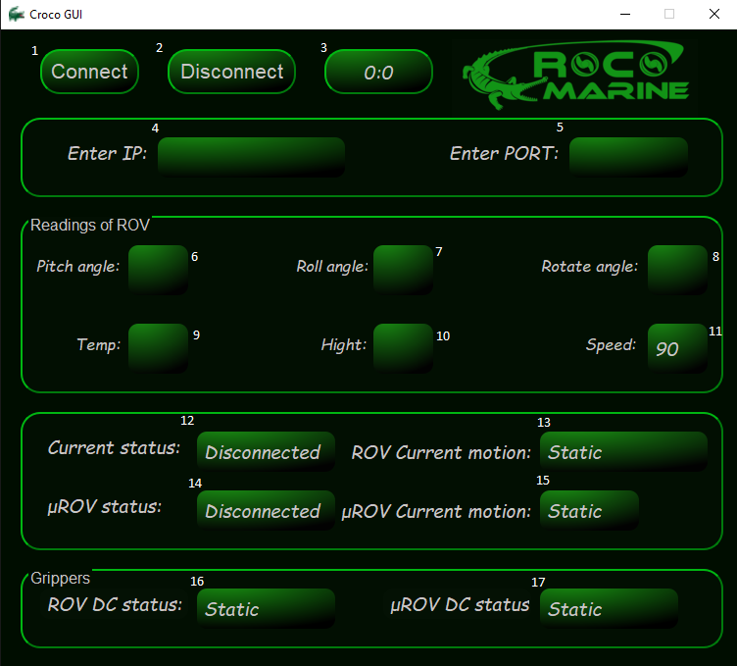**The graphical interface:**

1. Connect button to start connecting .
2. Disconnect button to close connection and program, it also has a confirmation message.

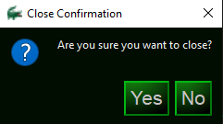

1. The timer that starts by pressing select on ROV controller, it’s set to count the 15 minutes allowed to finish the tasks.
2. Place to enter the IP you want to connect to.
3. Place to enter the port you want to connect to.
4. Shows the pitch angle given by the IMU code in degree.
5. Shows the roll angle given by the IMU code in degree.
6. Shows the rotate angle given by the IMU code in degree.
7. Shows the temprature given by the IMU code in C.
8. Shows the temprature given by the IMU code in meter.
9. Shows the actual speed of the ROV, default speed is 90.
10. Shows the status of the socket connection, activated to connected when the socket is connected.
11. Shows the current motion of the ROV.
12. Shows the status of micro ROV wheather it’s activated or not.
13. Shows the current motion of the micro ROV.
14. Shows the status of the DC gripper in the ROV.
15. Shows the status of the DC gripper in the micro ROV.

**Libiraries used:**

Time libirary to make use of the sleep method.

Threading libirary.

Pygame libirary to use controllers.

Sys libirary.

OS libirary.

PyQt5 libirary.